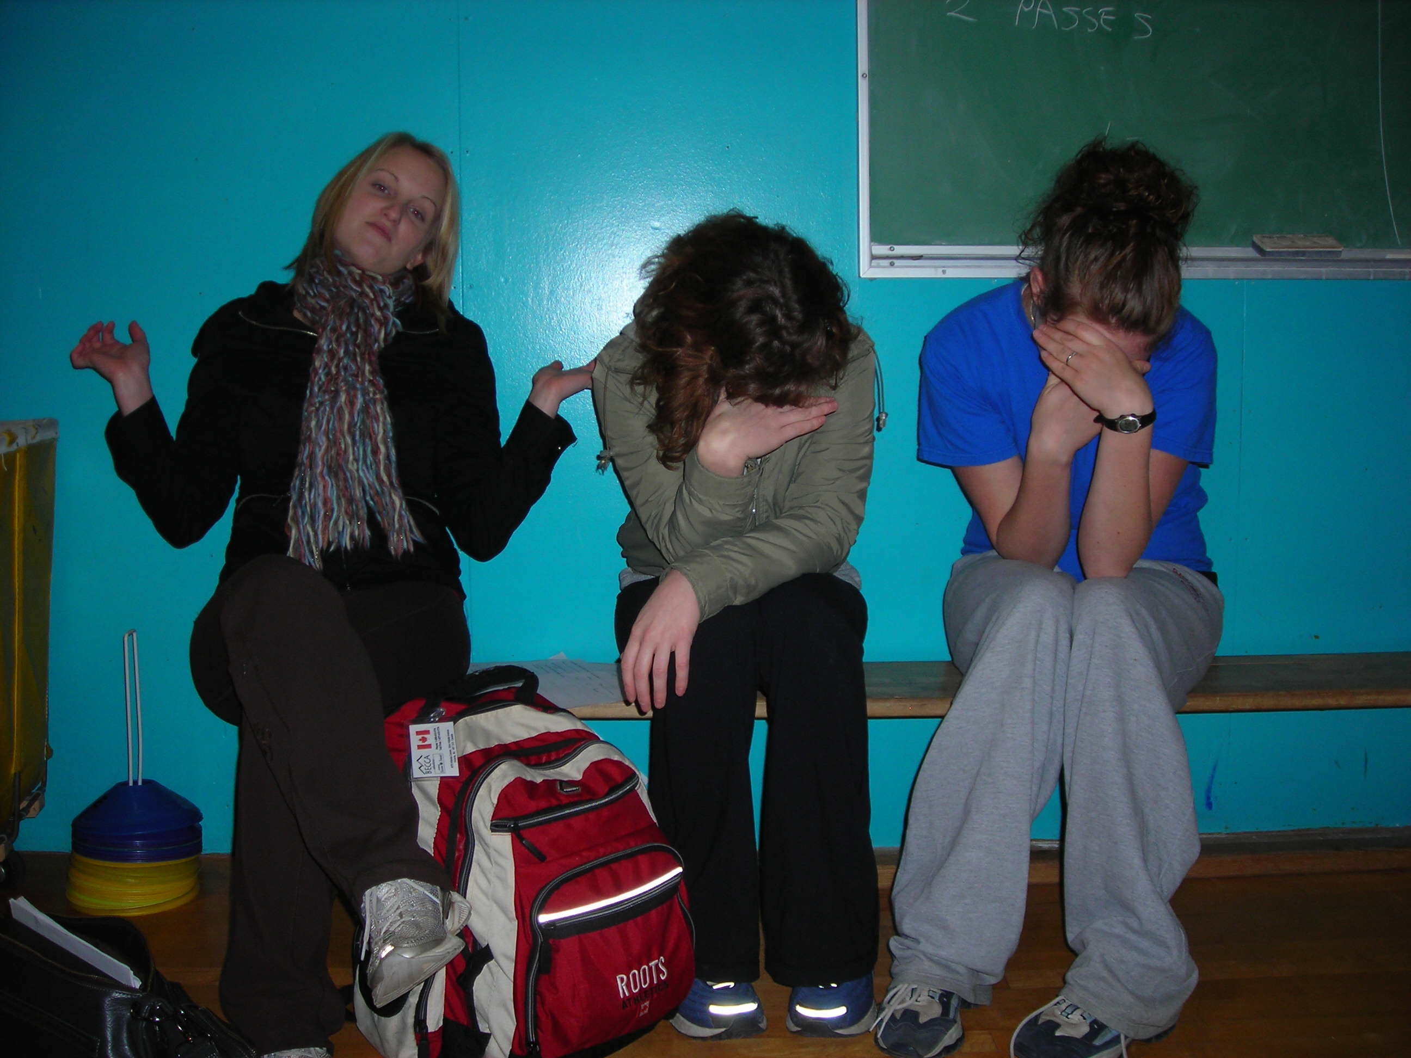
A Sad Day for Twinkle-Toes
The team, of usually high spirits and many laughs, was having some tough luck in Regina. After a night of stargazing in the wide open prairies for shooting stars (none of which we really saw, so we began to count satellites as shooting stars, that made our numbers go up), we woke up to find Darren missing. We first thought maybe he had woke early and gone on ahead of us to stake out a good diner in the next town over, but when we got there no sign of him was to be found. Gail, frantic with worry, and not paying attention to where she was stepping accidentally tripped over a pothole and had to be rushed to hospital. The next week is going to be a tough one, we’ve lost our two biggest bonus winners and as it turns out Gail’s accidental injury required immediate surgery. We wish our partner a steady recovery as we soldier on without her. (readers be assured to know that Darren was finally found, turns out he took a wrong turn; although in prairie flatland I’m not to sure how that is possible & Gail’s surgery went off without a hitch) Ok team, last week to go! Let’s do this!

